GIT REMOTING

Objective: Pushing source code into GITHUB & collaborate team members.

SECTION-1 (Pushing assignments to remote repository) - Steps to follow:

39. Create a github account if you do not have already.

40. Login on into github account

.41. Create new public repository ‘freshersbatch-oct16

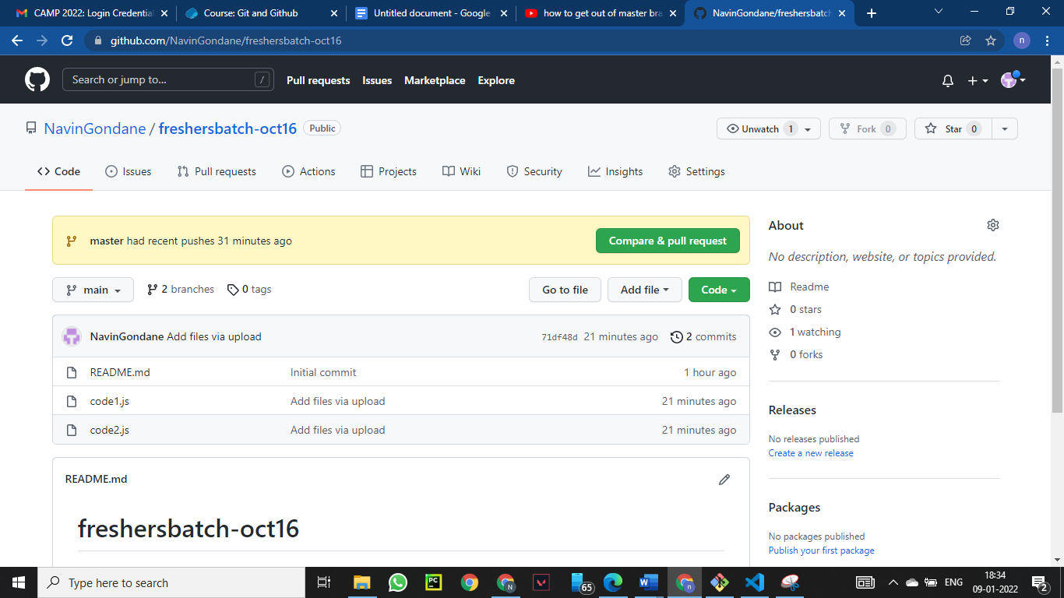

42. Commit & push any sample file to this repository under ‘Assignments’ directory.

